Installing Python On Windows
- Head over to https://www.python.org/downloads/windows/ and download the latest Python 2 release; it’s very important to get Python 2 and not Python 3.
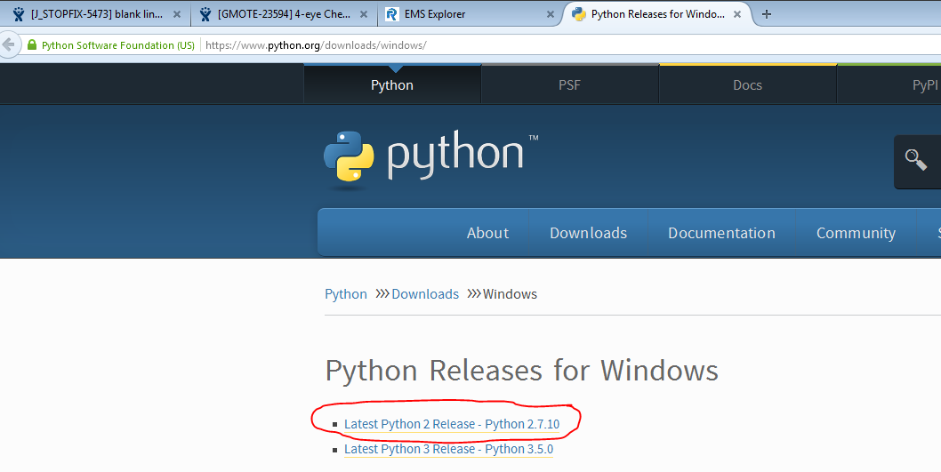
- After your download is complete, find the installer that downloaded and run it to install Python. Keep clicking next in order to download it in the default location.
- Check that it works!
  - First we check that Python works by bringing up the command line. You do this by clicking on start and searching for “CMD”:
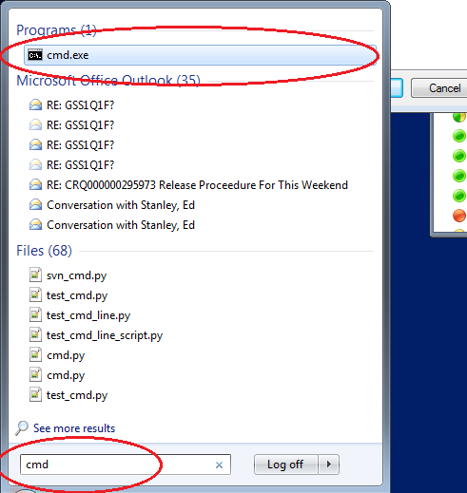
  - What all of this means will be explained when we see you, but to test that Python works simply type into the command window (without the speech marks and that is a double hyphen):
“python --version”
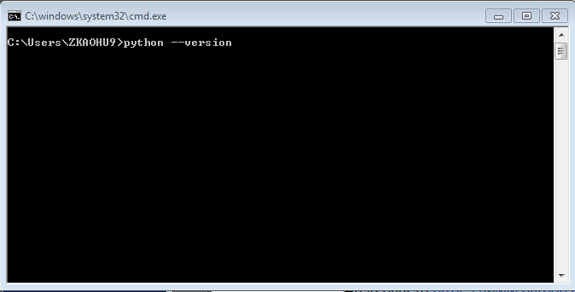
  - Press the enter key on your keyboard and you should see something like this:
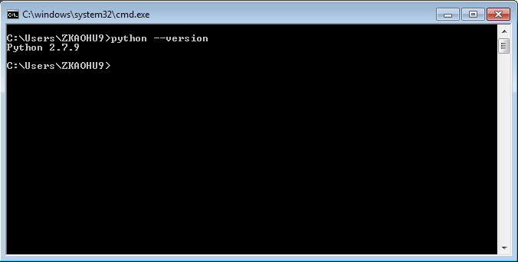
  - Don’t worry if it says Python 2 with some other numbers after it, the latest version of Python is just different to what it was when I wrote this guide! As long as it doesn’t look like this:
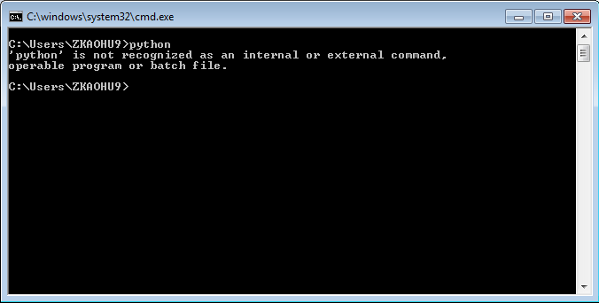
- OMG! My screen looks like that! Don’t worry, this is annoyingly common but quite easy to fix:
  - Basically, when you type a command into the windows command line, like ‘python’, windows has a list of commands that it knows of like ‘open’ and ‘copy’, and if it doesn’t recognise the command, it has a list of folders (directories) hidden away somewhere that it will look in for things that are called the command you typed. We need to add the location of where you installed Python to that list!
  - Click start and search for “Edit the System Environment Variables” make sure you click on “Edit the system environment variables”, not “Edit the user environment variables”:
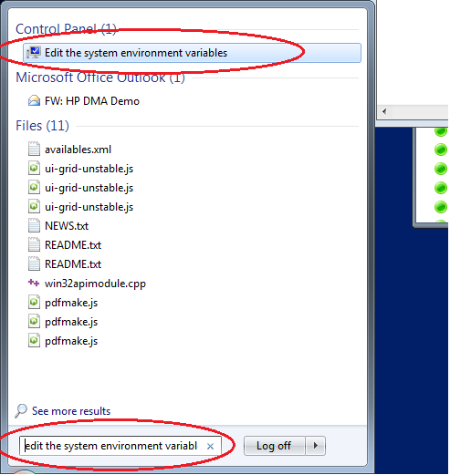
On Windows 8 it may not appear, next to the search bar on the start menu make sure it is set to “Search the web and Windows” or just “Windows”, as if it’s set to “the web” it won’t find the thing we’re looking for!

  - Click on the “Advanced” tab:
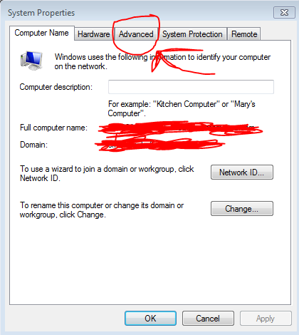
  - Then the Environment Variables... button
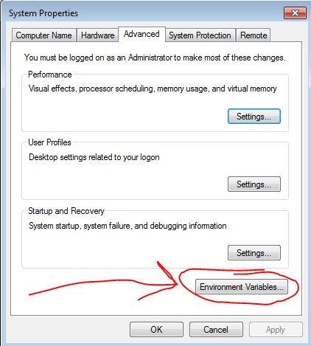
  - Now please be careful here, as changing something here that you don’t mean to could do bad things!
  - On the bottom list of variables (labelled “System Variables”) scroll down and find the one called “PATH” or “Path”.
  - Click on the variable called “PATH” or “Path” and then click the Edit button:
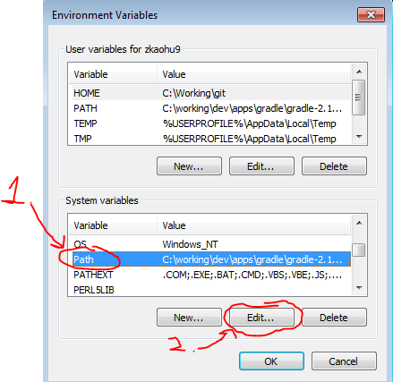
  - In the “Variable value” box there is a list of paths to folders (directories) on your computer, where each one is separated by a semicolon. We are going to add two more, so go to the end of the list and put this at the end “;C:\Python27\;C:\Python27\Scripts” (without speech marks and this is case sensitive!). If your list already ended in a semicolon then don’t put that first semicolon.
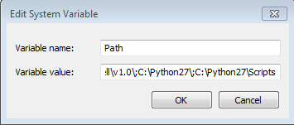

  - Not like this:
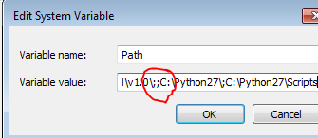
- Now press ok a lot and go back to step 3 and check that Python works!
Make sure you open a new cmd window or it will not work!!!

If it still doesn’t work, email your instructor, post your problem on howcloud, or wait till the first session and ask us in person.

